H.T No
Regulations:
A18

Sreenidhi Institute of Science and Technology
(An Autonomous Institution)
Code No: 7HC06 Date: 18-Mar-2023 (AN)

B.Tech I-Year I- Semester External Examination, March/April-2023 (Supplementary)
ENGINEERING MATHEMATICS - I (CIVIL, EEE, ME and ECE)

Time: 3 Hours Max.Marks:70

Note: a) No additional answer sheets will be provided.
b) All sub-parts of a question must be answered at one place only, otherwise it will not be valued.
c) Missing data can be assumed suitably.
Bloom's Cognitive Levels of Learning (BCLL)

Remember | L1 | Apply | L3 | Evaluate | L5
Understand | L2 | Analyze | L4 | Create | L6

Part - A Max.Marks:20

Answer all QUESTIONS.

 |  | BCLL | CO(s) | Marks
1 | State Rolle’s theorem. | L2 | CO1 | [2M]
2 | Define gamma function. | L1 | CO2 | [2M]
3 | Write Parseval’s formula. | L2 | CO3 | [2M]
4 | 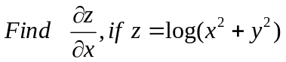 | L3 | CO4 | [2M]
5 | Define rank of a matrix. | L1 | CO5 | [2M]
6 | Define Eigen vector. | L1 | CO6 | [2M]
7 | Write the relation between beta and gamma functions. | L4 | CO2 | [2M]
8 | Define Solenoidal vector. | L1 | CO4 | [2M]
9 | Find the Eigen values of 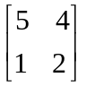 | L5 | CO6 | [2M]
10 |  | L5 | CO1 | [2M]

Part – B Max.Marks:50
ANSWER ANY FIVE QUESTIONS. EACH QUESTION CARRIES 10 MARKS.

 |  |  | BCLL | CO(s) | Marks
11. | a) | 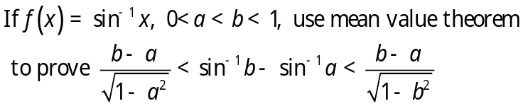 | L3 | CO1 | [5M]
 | b) | 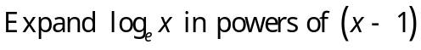 | L5 | CO1 | [5M]
12. | a) | Evaluate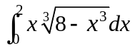 | L5 | CO2 | [5M]
 | b) | Find the volume of the solid generated by revolving the ellipse 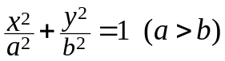about the major axis. | L3 | CO2 | [5M]
13. | a) | 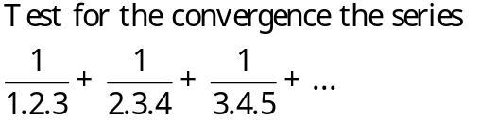 | L2 | CO3 | [5M]
 | b) |  | L4 | CO3 | [5M]
14. | a) | 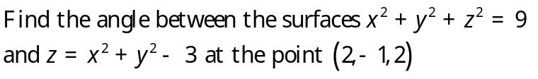 | L3 | CO4 | [5M]
 | b) |  | L2 | CO4 | [5M]
15. | a) | Reduce the matrix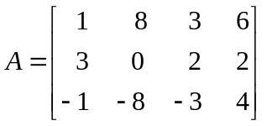into normal form and hence  find its rank. | L1 | CO5 | [5M]
 | b) | Solve the system of equations 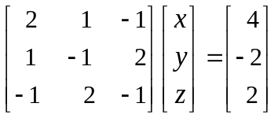 | L3 | CO5 | [5M]
16. |  | Determine the Eigen values and Eigen vectors of 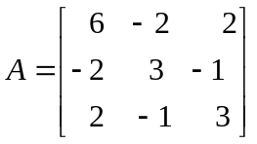 | L4 | CO6 | [10M]
17. | a) | Obtain Maclaurin’s series expansion of 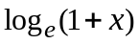 | L4 | CO1 | [5M]
 | b) | Express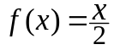 as a Fourier series in 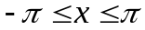 | L1 | CO3 | [5M]
18. | a) | If 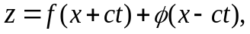prove that 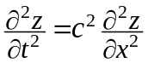 | L5 | CO4 | [5M]
 | b) | Find the inverse of a matrix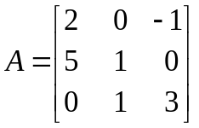using Gauss-Jordan method. | L3 | CO5 | [5M]

-- 00 -- 00 –

